Lab 1 Questions

What is the recommended salary for the Syracuse football coach?

According to the ordinary least squares regression model conducted on the data, the Syracuse coach should make 1,674,607 dollars rounded or around 1.7 million dollars. This is somewhat lower than his reported 2.4 million in total salary

What if we went to the Big Ten?

I conducted an additional training set of least squares on the Big Ten set of data, but the schools are limited. The model predicted that the Syracuse Coach being in the Big Ten and using the same set of regressors would make 3,776,070 or roughly 3.8 million dollars in total salary

What schools did we drop from our data, and why?

I was forced to drop schools that were not part of the FBS in the 2013 season because they had no data outside of the original DF including attendance rates and wins or losses etc.

What effect does graduation rate have on the projected salary

The graduation rate doesn’t appear to have any affect on the projected salary. As you can tell by the graphs below, there doesn’t appear to be any relationship between these variables and you can also note it in the correlation matrix in my Supporting notebook. The correlation matrix indicated a correlation of only .16 for GSR and Total Salary and FGR only at .011 correlation.

How good is our model?

The model accounts for about 75 percent of the changes in variation that alter the Total Salary a coach receives

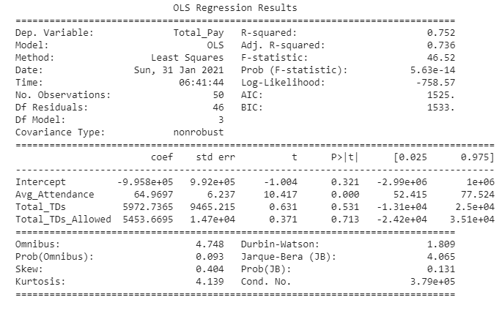

What is the single biggest impact on salary size?

It appears that Average Attendance at games seems to be the biggest factor in determining how much salary a coach earns. This makes sense from a money-making standpoint and it would make sense that larger stadiums with more capacity would be more lucrative and allow for a coach to be paid more. Unfortunately, the data doesn’t indicate that having more capacity means more wins either.

